# Case Study

* G Joshita Reddy

Azure DevOps - <https://dev.azure.com/joshitareddy/Case%20Study%20Joshita>

GitHub Link - [JoshitaReddy/Foundational-Training (github.com)](https://github.com/JoshitaReddy/Foundational-Training)

## SLDC, Agile & Software Testing

1. Access Azure Portal
2. Create Azure VM

1. Azure DevOps Portal 🡪 project

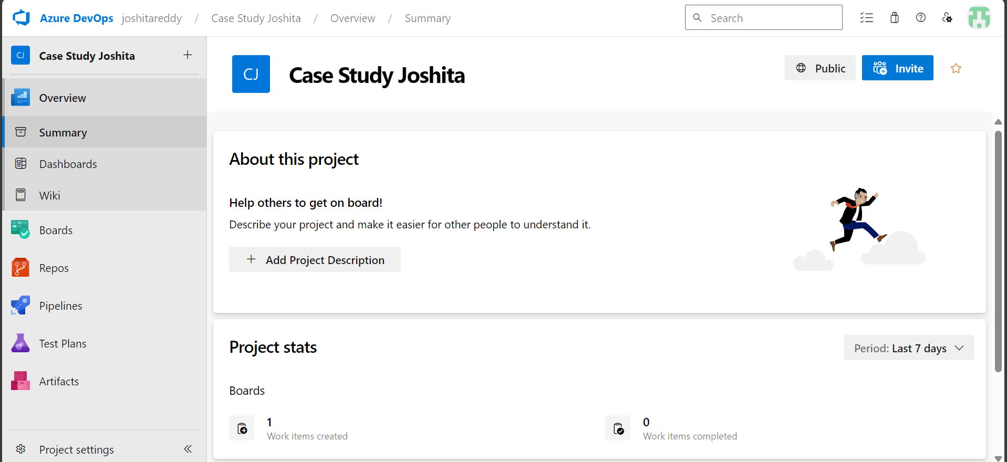

1. Create Sprints

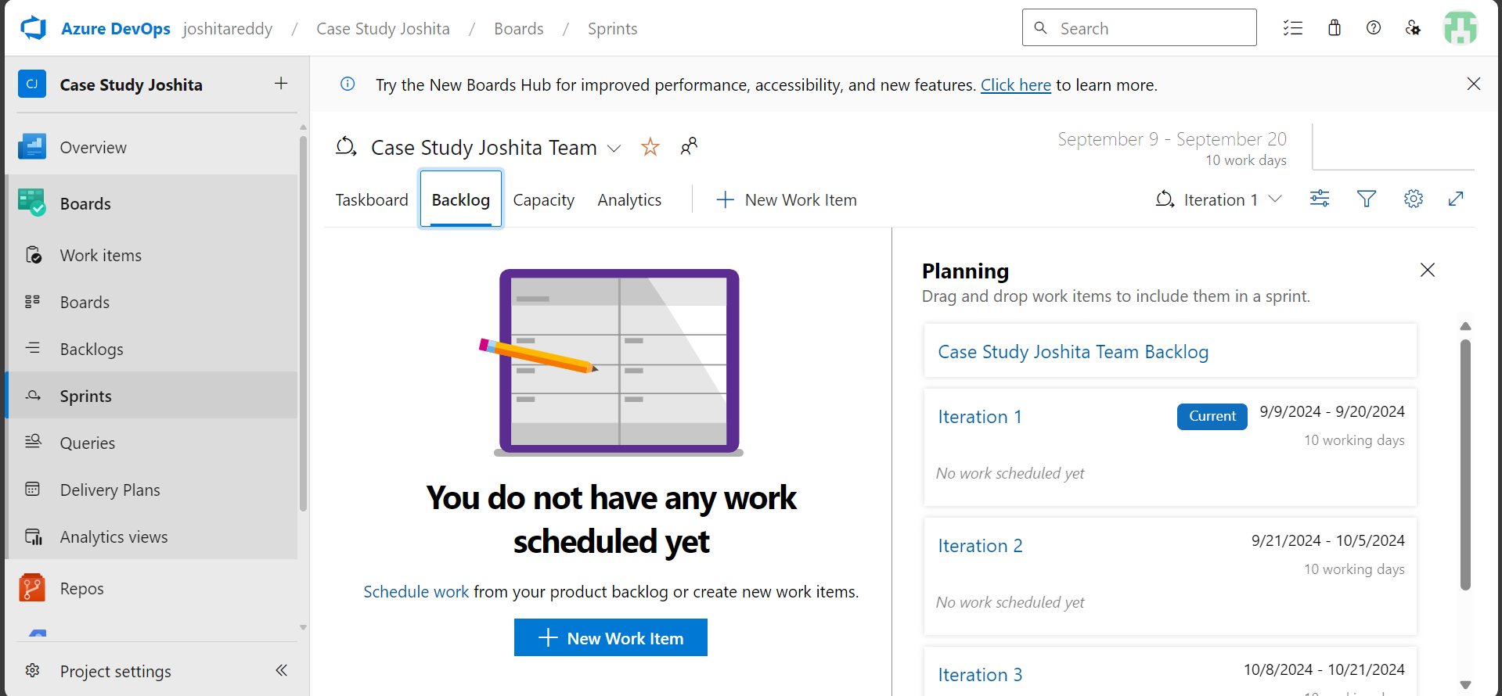

1. User Stories

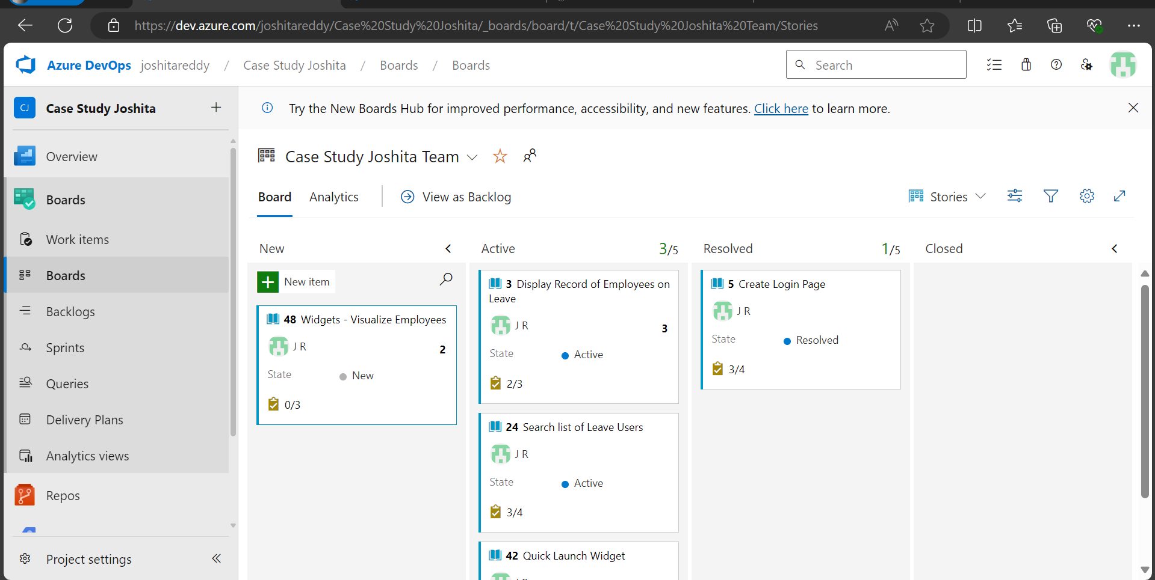

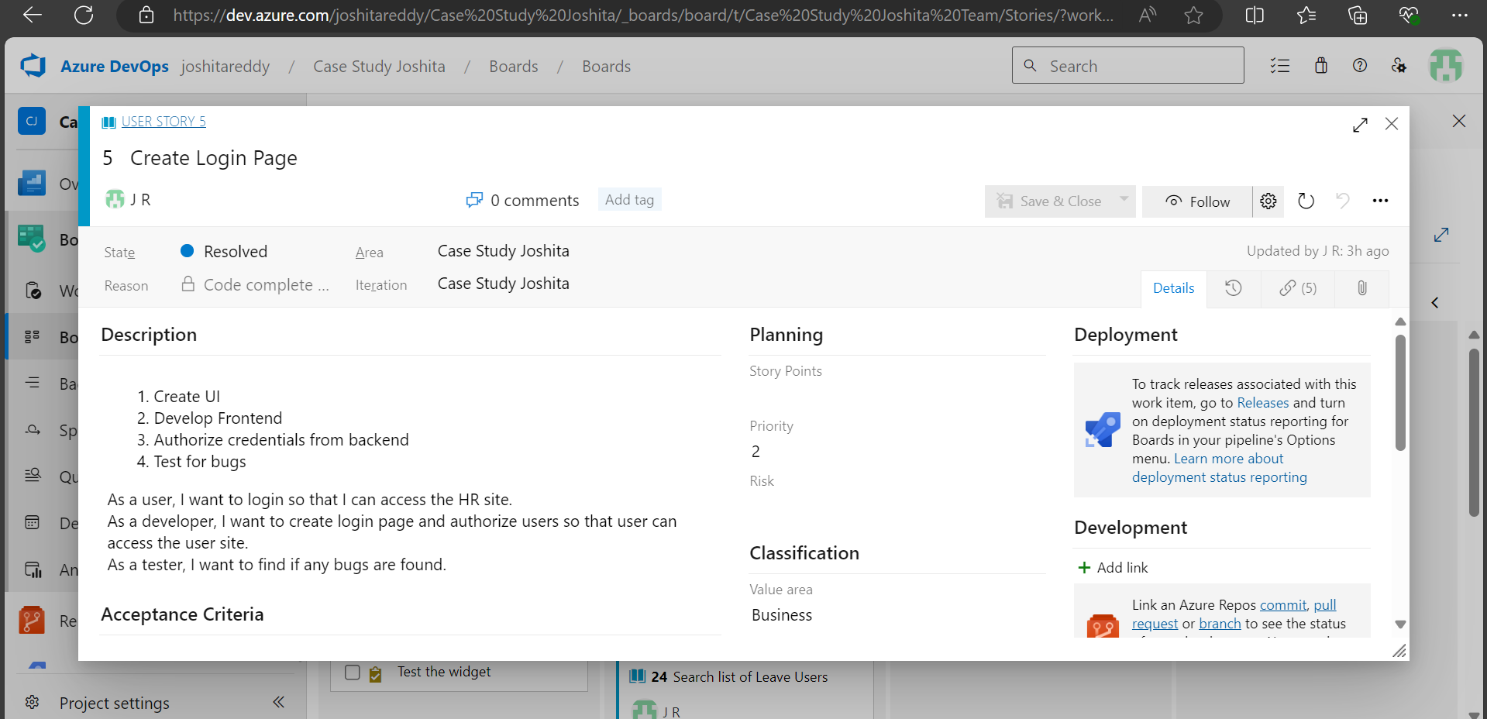

1. Test Cases

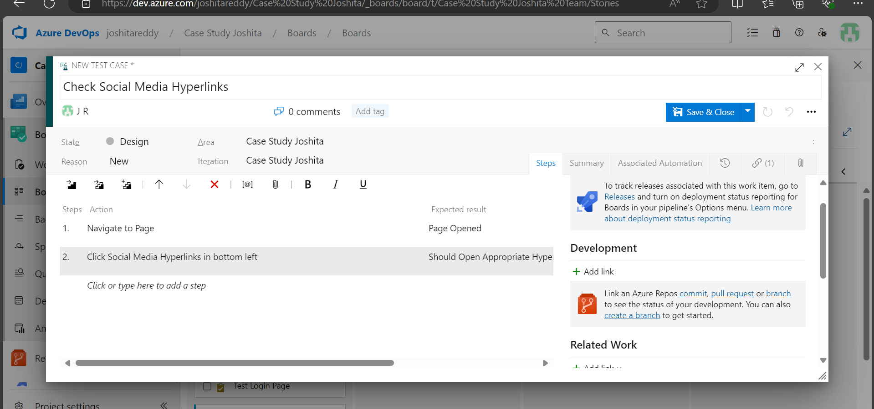

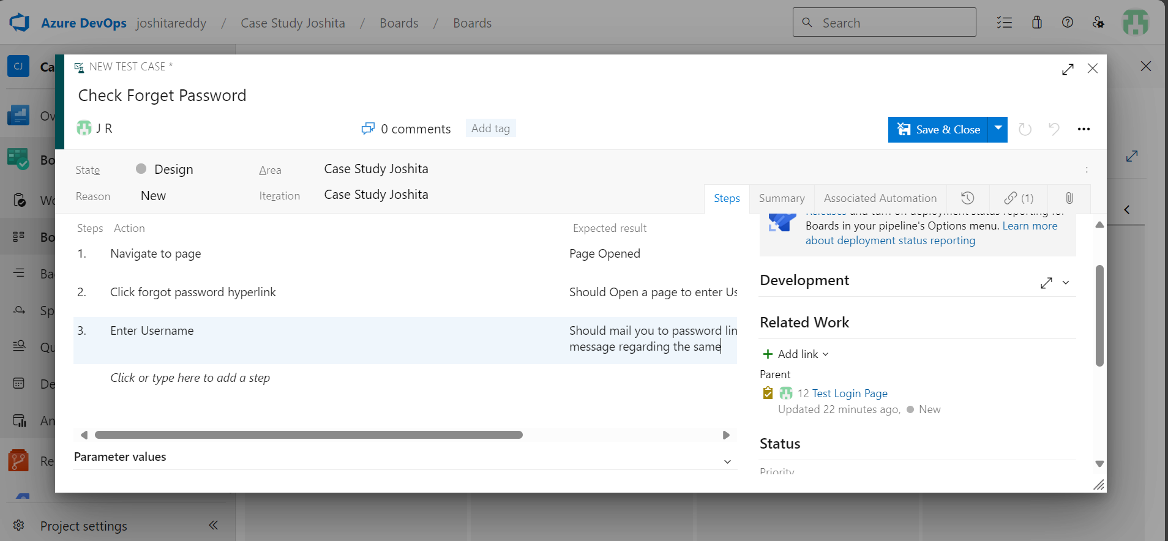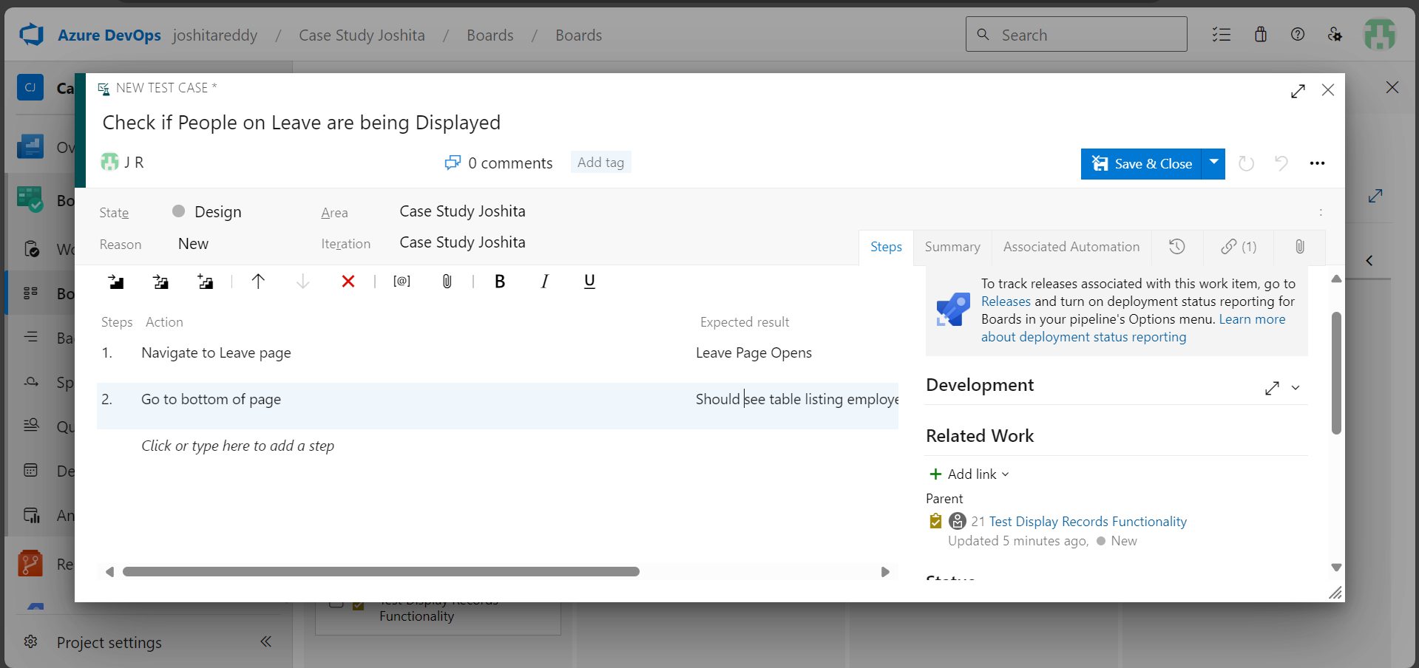

1. Task

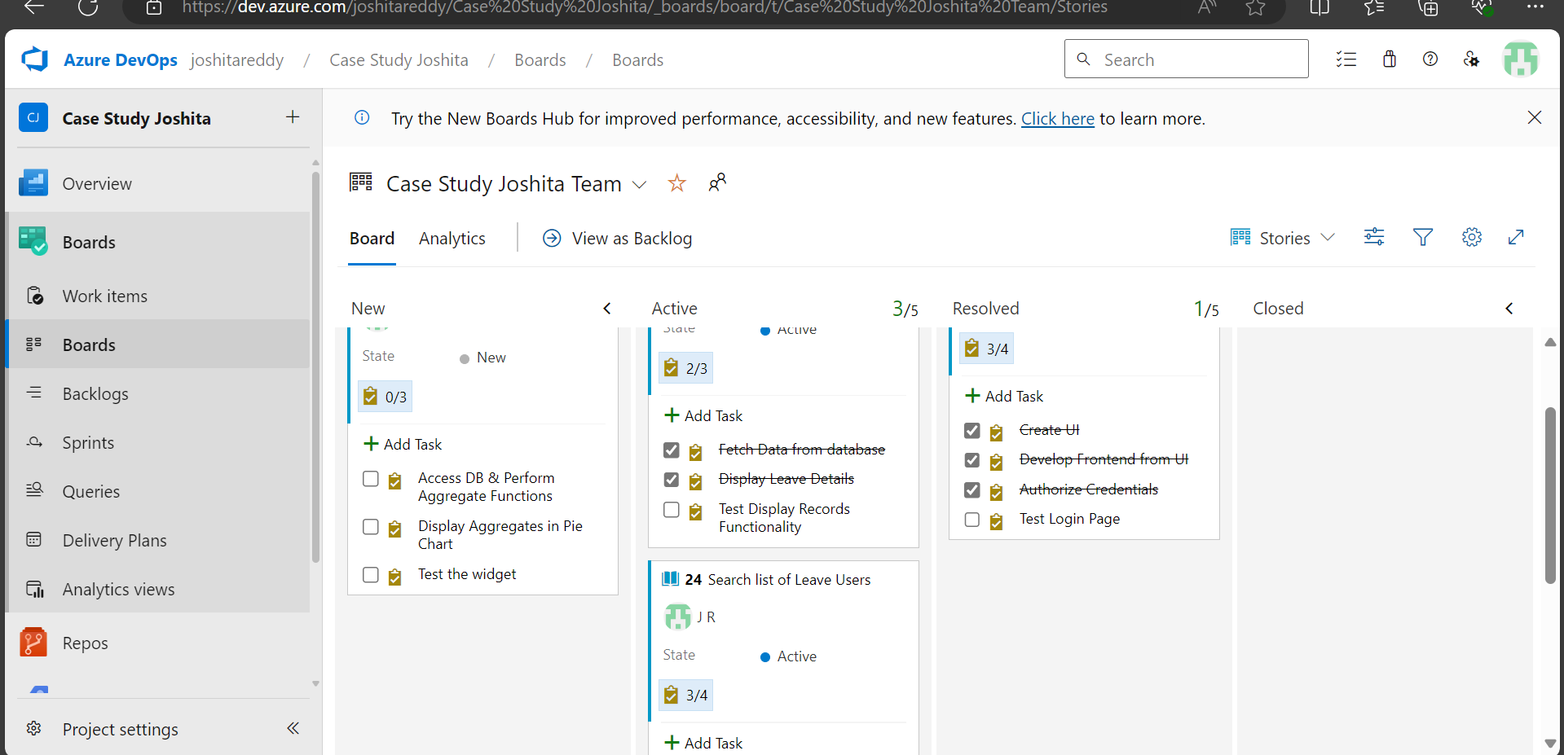

1. Test Cases – Manual testing

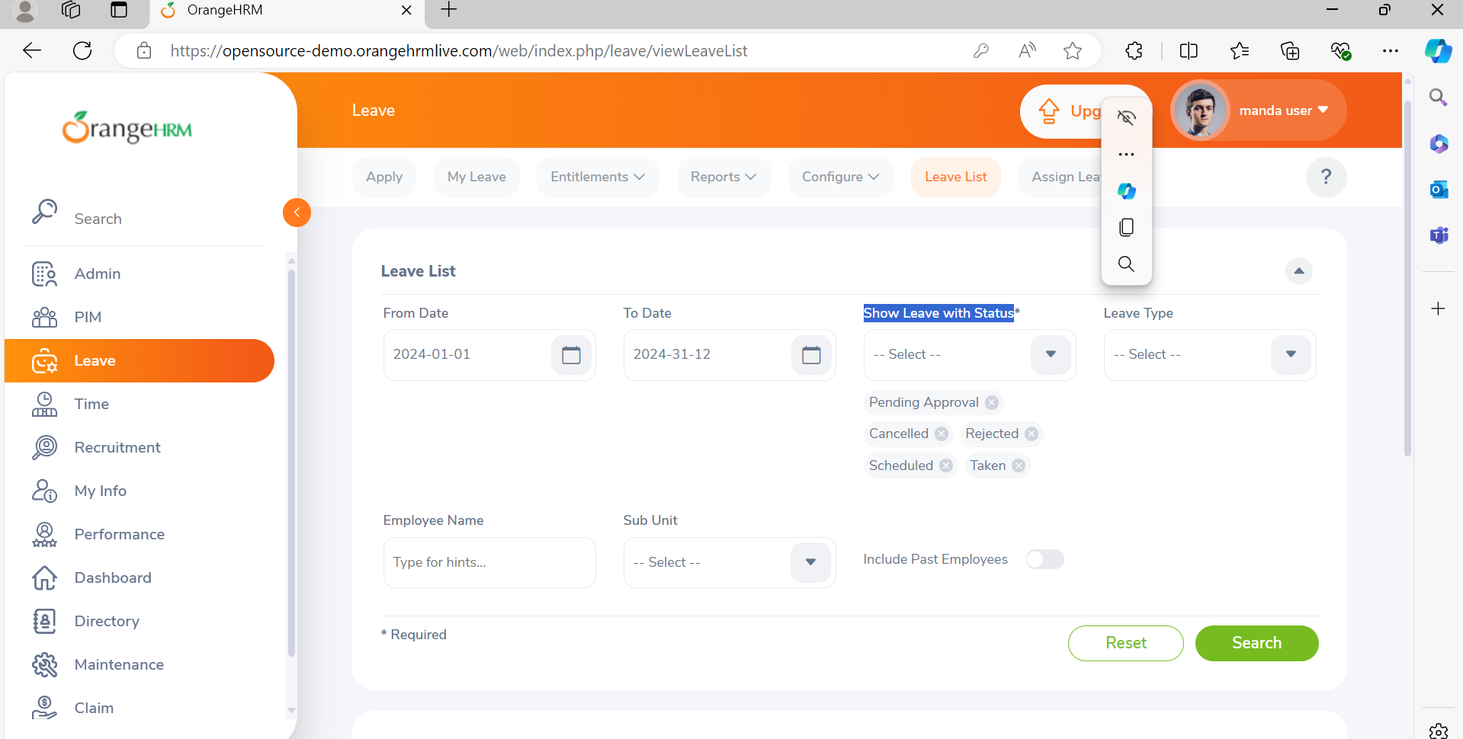

1. Defect Report

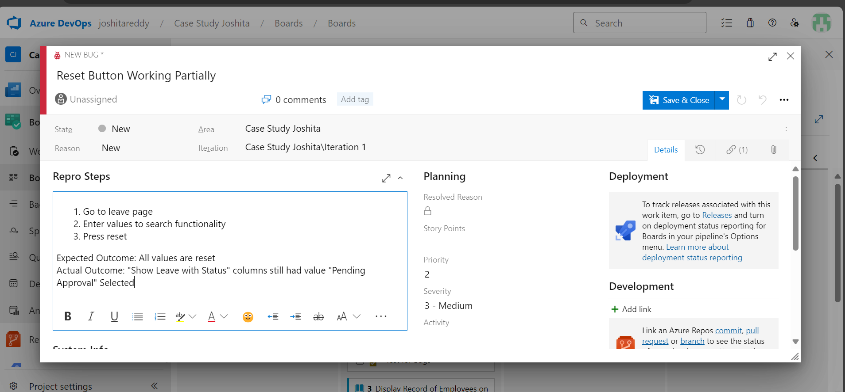

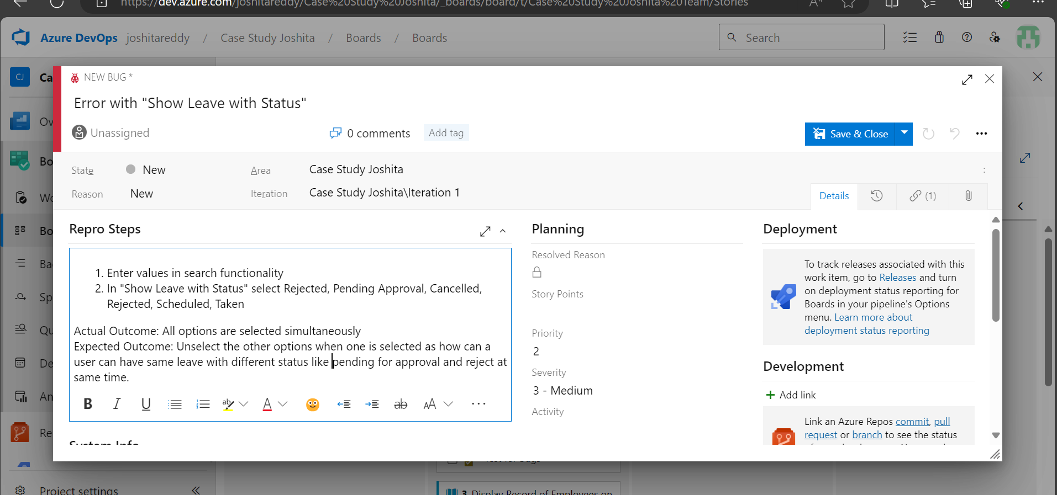

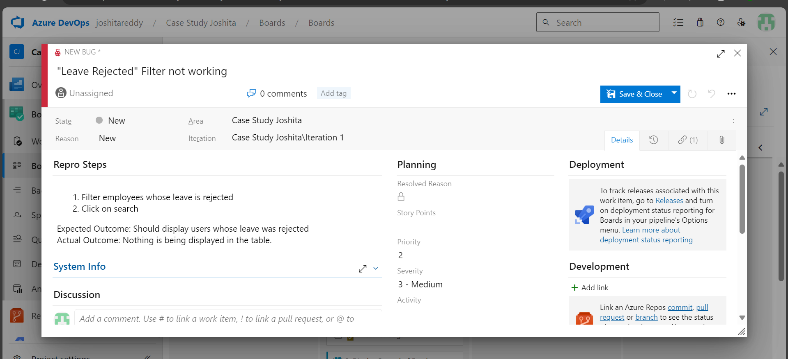

## GitHub Actions

1. GitHub Repository

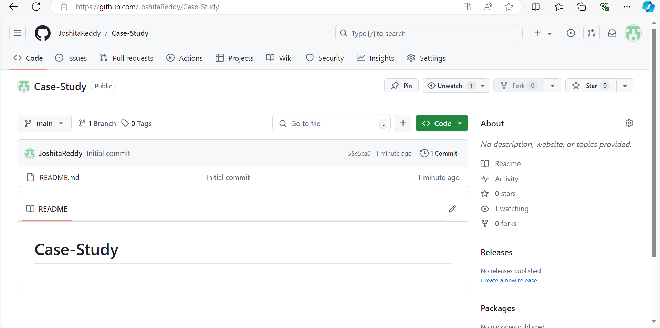

1. Git Clone

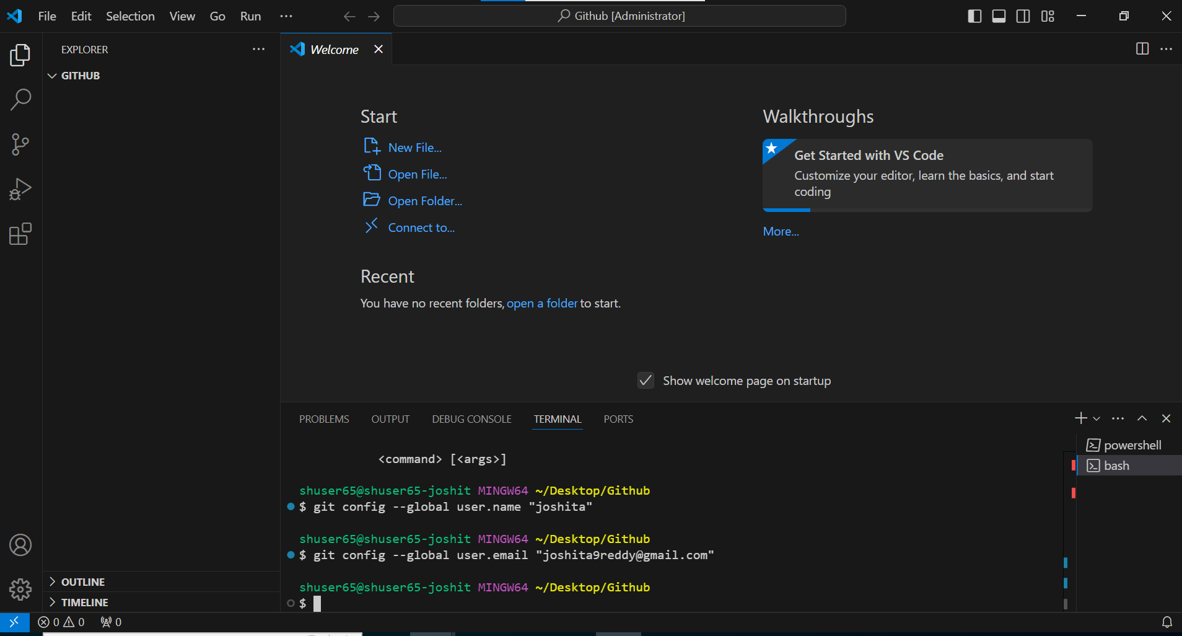

1. Workflow

1. Build

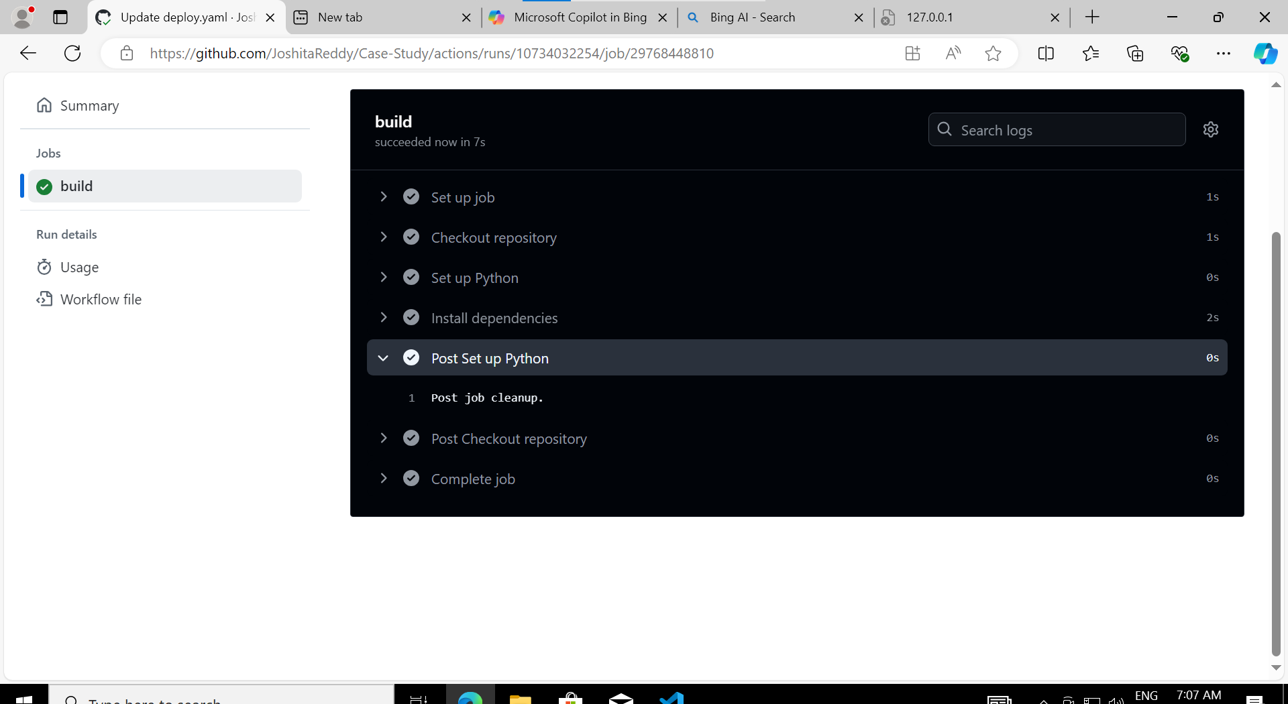

1. Make change – Unittest

1. Monitor Build Again

1. Update SS to repository

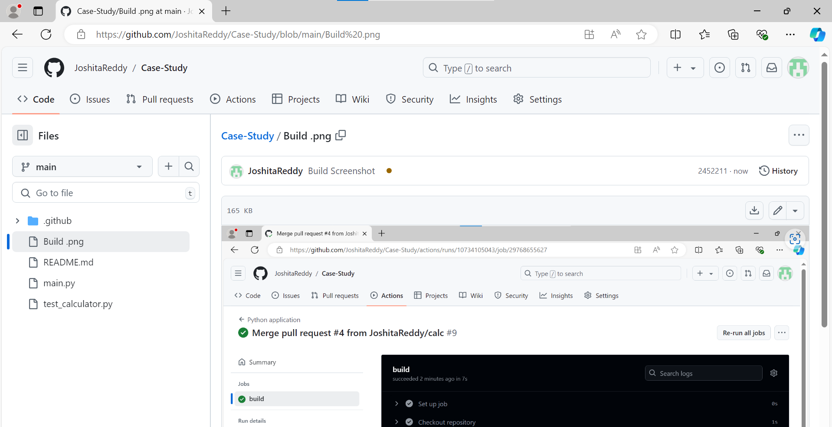

1. Testing

